

|  |  |
| --- | --- |
|  | Quartic function of r, this is the equation that is going to be fit between the 2 spokes. We know r at theta=0 and theta=max, which are the radius of the two spokes. |
| Evaluate the expression at theta=max | q0 is a parameter, corresponding to the derivative of r at theta=0.  drend is another parameter corresponding to the derivative at theta=max |
|  | This function is minimized using non linear least squares i.e. find the best q1 such that the overall curvature is minimized. |
| Using  We solve for q2 | Using the second derivative equation we can find and expression that depends on q1, q3 and the parameters drend and q0 |
| Using and replacing the expression of q2 from last step we solve for q3 | Here we have an expression for q3 that depends on the radius r0, rend and q0 (all parameters).  q1 is found from the optimization problem.  Once we have solve q3 we can replace this value on the expression for q2 and we have the 3 coefficients necessary to compute the sum squared values using with theta [0, thetamax] in order to find the q1 such that the overall curvature is minimized. |
|  |  |
|  |  |
|  |  |

Examples: drend = -1 and dr0 = 0

The red spoke is the middle spoke (crest spoke) at theta = 0

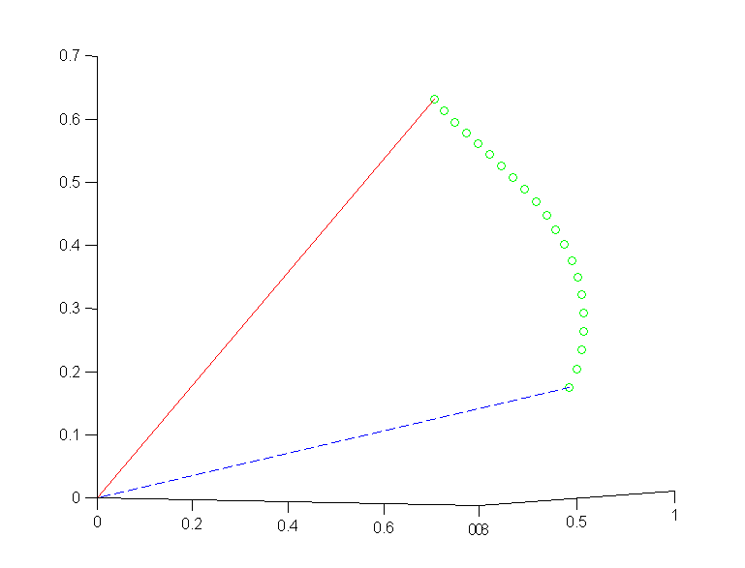

drend = 1 and dr0 = 0

Note the change at the end of the blue spoke, meeting drend = 1

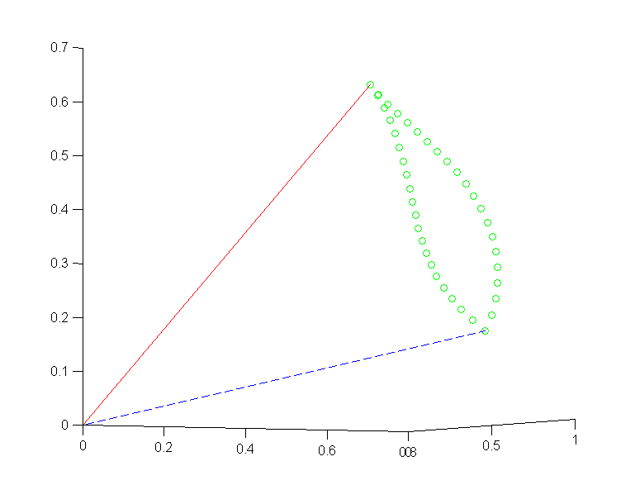

One final example drend = 0 and dr0 = 0

